Trabalho 2 de Análise de Série Temporal

**Carlos Lopes, Cristiane Fractal, Cristovão Moreira Freitas Junior, Fábio Karpusca Marin, Renato Bastos Pope**

20/04/2021

## Apresentação do caso:

Despesas de telefonia móvel – Banco X Os dados apresentados são referentes a despesas somadas de todos os contratos de prestação de serviço de telefonia móvel, de janeiro de 2015 até março de 2021. Ao longo desse período foram assinados 12 contratos, com vigência de 5 anos cada, para uma média de 18.000 linhas ativas entre 2015 e 2019, e 25.000 linhas ativas a partir de 2020. Até o final de 2020 os contratos faturavam os seguintes serviços:

* Assinatura mensal da linha e cessão de comodato do dispositivo;
* Ligações telefônicas, por minuto e por destinação;
* SMS;
* Pacote de dados;
* Roaming nacional e internacional;
* Outros serviços de valor agregado.

A partir de 2021 os contratos passarão a faturar os seguintes serviços:

* Assinatura mensal da linha incluindo pacote de dados;
* Ligações nacionais, SMS e roaming nacional são ilimitados, sem custo adicional;
* Roaming internacional e outros serviços de valor agregado são cobrados à parte.

## Importar a base de dados

Dados_Telefonia_Movel <- read_excel("Dados Telefonia Movel.xlsx")  
db <- Dados_Telefonia_Movel

Converter a base de dados em série temporal:

db_ts <- ts(db$`Telefonia Móvel`, start=c(2015, 1), end=c(2021, 3), frequency = 12)

## Análise estatística da série:

summary(db_ts)

## Min. 1st Qu. Median Mean 3rd Qu. Max.   
## 342538 950886 1130180 1339072 1450561 6012284

## Plotar o gráfico da série temporal:

plot(db_ts, xlab="Tempo", ylab="Despesas", ylim=c(342000, 6013000), type="l", main="Série Temporal")

## Definir o tamanho da amostra de treinamento e da amostra de teste:

amostra_validacao <- 20  
amostra_treino <- length(db_ts) - amostra_validacao

## Programar a amostra de treinamento:

treinamento_ts <-window(db_ts, start=c(2015, 1), end=c(2015, amostra_treino))

## Programar a amostra de validação:

validacao_ts <- window(db_ts, start=c(2015, amostra_treino + 1), end=c(2015, amostra_treino + amostra_validacao))

## PLotagem do gráfico do treinamento com validação:

plot(treinamento_ts, xlab="Tempo", ylab="Despesas", xaxt="n" , ylim=c(342000, 6013000), xlim=c(2015, 2021), type="l", main="Treinamento e Validação")  
axis(1, at=seq(2015, 2021,1), labels=format(seq(2015, 2021,1)))  
lines(validacao_ts, bty="l", col="red")

## Confecção do modelo Naive:

modelo_naive <- naive(treinamento_ts, level=0, h=amostra_validacao)  
accuracy(modelo_naive, validacao_ts)

## ME RMSE MAE MPE MAPE MASE  
## Training set -10955.18 1122711.5 621341.4 -17.33006 42.30944 0.6597082  
## Test set 276316.56 556863.3 325664.9 12.32497 18.23478 0.3457742  
## ACF1 Theil's U  
## Training set -0.2828524 NA  
## Test set 0.0563613 0.9234698

Grafico da série temporal de treinamento, validação e modelo naive

plot(modelo_naive, xlab="Tempo", ylab="Despesas", xaxt="s" , ylim=c(342000, 6013000), xlim=c(2015, 2021), bty="l", flty=2, main="Previsão do Modelo Naive")  
axis(1, at=seq(2015, 2021,1), labels=format(seq(2015, 2021,1)))  
lines(validacao_ts, bty="l", col="red")

## Modelo de Tendência linear:

modelo_tendencia_linear <- tslm(treinamento_ts ~ trend)  
summary(modelo_tendencia_linear)

##   
## Call:  
## tslm(formula = treinamento_ts ~ trend)  
##   
## Residuals:  
## Min 1Q Median 3Q Max   
## -977724 -463807 -213912 128175 4687242   
##   
## Coefficients:  
## Estimate Std. Error t value Pr(>|t|)   
## (Intercept) 1315746.6 252456.3 5.212 3.14e-06 ***  
## trend 265.6 7843.4 0.034 0.973   
## ---  
## Signif. codes: 0 '***' 0.001 '**' 0.01 '*' 0.05 '.' 0.1 ' ' 1  
##   
## Residual standard error: 923400 on 53 degrees of freedom  
## Multiple R-squared: 2.163e-05, Adjusted R-squared: -0.01885   
## F-statistic: 0.001147 on 1 and 53 DF, p-value: 0.9731

plot(modelo_tendencia_linear$residuals, xlab="Tempo", ylab="Resíduos", bty="l", main="Resíduos do modelo de regreção linear")  
lines(modelo_tendencia_linear$fitted.values, lwd="2", col="orange")

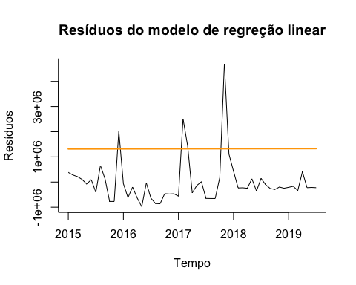

Acf(modelo_tendencia_linear$residuals, main="Modelo de Tendencia Linear")

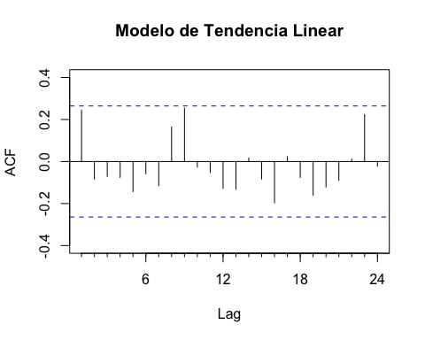

checkresiduals(modelo_tendencia_linear, test="LB")

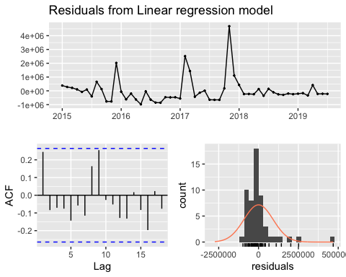

##   
## Ljung-Box test  
##   
## data: Residuals from Linear regression model  
## Q* = 13.368, df = 9, p-value = 0.1467  
##   
## Model df: 2. Total lags used: 11

plot(treinamento_ts, xlab="Tempo", ylab="Despesa", bty="l", main="Modelo com Tendência")  
lines(modelo_tendencia_linear$fitted.values, lwd="2", col="orange")

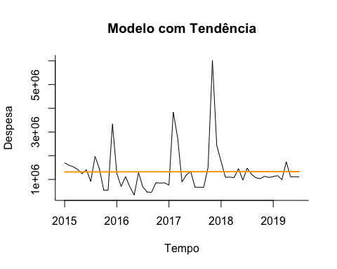

modelo_tendencia_linear_proj <- forecast(modelo_tendencia_linear, h=amostra_validacao, level=0.95)  
  
plot(modelo_tendencia_linear_proj, xlab="Tempo", ylab="Despesas", xaxt="n" , xlim=c(2015, 2021.75), bty="l", flty=2, main="Projeção do Modelo de Regressão Linear")  
axis(1, at=seq(2015, 2021, 1), labels=format(seq(2015,2021,1)))  
lines(validacao_ts, col="red")  
lines(modelo_tendencia_linear_proj$fitted, lwd="2", col="blue")

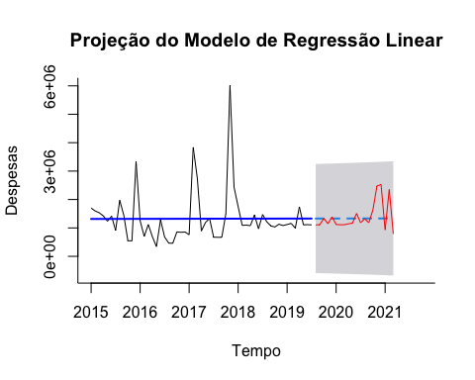

checkresiduals(modelo_tendencia_linear, test="LB")



##   
## Ljung-Box test  
##   
## data: Residuals from Linear regression model  
## Q* = 13.368, df = 9, p-value = 0.1467  
##   
## Model df: 2. Total lags used: 11

accuracy(modelo_tendencia_linear_proj, validacao_ts)

## ME RMSE MAE MPE MAPE MASE  
## Training set 3.600772e-11 906451.5 543025.5 -31.190011 49.06136 0.5765564  
## Test set 4.962528e+04 485395.9 338812.5 -5.631544 22.73450 0.3597336  
## ACF1 Theil's U  
## Training set 0.24473472 NA  
## Test set 0.05374474 0.7712741

Pelo baixo valor de R Square e AR-Squared, o Modelo de Tendência Linear não foi satisfatório. Partimos para o próximo modelo.

## Modelo de Tendencia linear com Sazonalidade

modelo_tendencia_linear_sazonalidade <- tslm(treinamento_ts ~ season+trend)  
summary(modelo_tendencia_linear_sazonalidade)

##   
## Call:  
## tslm(formula = treinamento_ts ~ season + trend)  
##   
## Residuals:  
## Min 1Q Median 3Q Max   
## -1581776 -442666 -73520 229384 3876568   
##   
## Coefficients:  
## Estimate Std. Error t value Pr(>|t|)   
## (Intercept) 1310468.7 470336.4 2.786 0.00797 **  
## season2 359198.3 600187.6 0.598 0.55274   
## season3 181747.3 600352.1 0.303 0.76359   
## season4 -152623.7 600626.1 -0.254 0.80065   
## season5 -252309.5 601009.5 -0.420 0.67676   
## season6 -95486.5 601502.1 -0.159 0.87463   
## season7 -349930.6 602103.7 -0.581 0.56423   
## season8 -235364.9 636588.6 -0.370 0.71344   
## season9 -406980.1 636743.7 -0.639 0.52619   
## season10 -332293.8 637002.1 -0.522 0.60465   
## season11 815159.4 637363.6 1.279 0.20793   
## season12 610086.8 637828.1 0.957 0.34429   
## trend 288.2 8112.9 0.036 0.97183   
## ---  
## Signif. codes: 0 '***' 0.001 '**' 0.01 '*' 0.05 '.' 0.1 ' ' 1  
##   
## Residual standard error: 948900 on 42 degrees of freedom  
## Multiple R-squared: 0.1632, Adjusted R-squared: -0.07589   
## F-statistic: 0.6826 on 12 and 42 DF, p-value: 0.7582

plot(modelo_tendencia_linear_sazonalidade$residuals, xlab="Tempo", ylab="Resíduos",ylim=c(-1500000, 4000000), type="l")

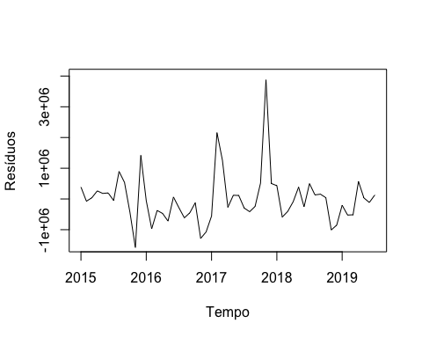

Acf(modelo_tendencia_linear_sazonalidade$residuals)

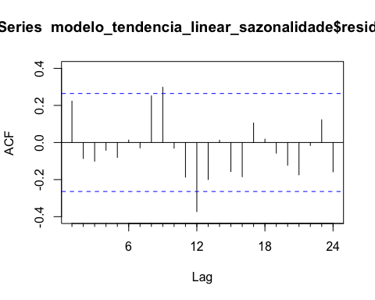

checkresiduals(modelo_tendencia_linear_sazonalidade, test="LB", main="Teste de Ljung-Box")

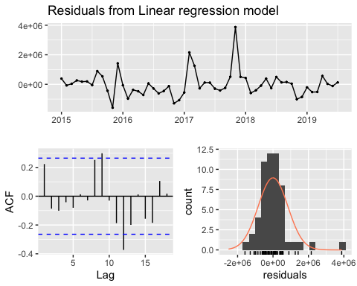

##   
## Ljung-Box test  
##   
## data: Residuals from Linear regression model  
## Q* = 35.139, df = 3, p-value = 1.139e-07  
##   
## Model df: 13. Total lags used: 16

plot(db_ts, xlab="Tempo", ylab="Despesas", ylim=c(342000, 6013000), type="l")  
lines(modelo_tendencia_linear_sazonalidade$fitted.values, lwd=2, col="Blue")

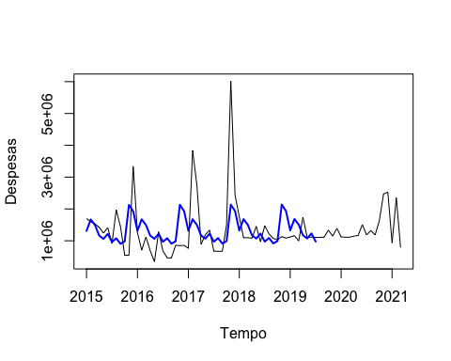

modelo_tendencia_linear_sazonalidade_proj <- forecast(modelo_tendencia_linear_sazonalidade, h = 55, level=0.95)   
  
plot(modelo_tendencia_linear_sazonalidade_proj, xlab="Tempo", ylab="Despesas", xaxt="s" , ylim=c(-1500000, 6013000), xlim=c(2015, 2021), type="l", flty=3)  
axis(1, at=seq(2015, 2021), labels=format(seq(2015, 2021)))  
lines(validacao_ts)  
lines(modelo_tendencia_linear_sazonalidade_proj$fitted, lwd=2, col="blue")

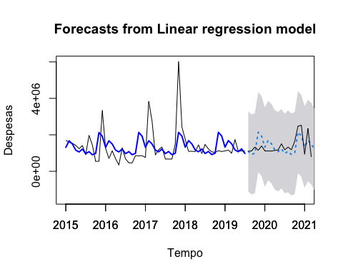

accuracy(modelo_tendencia_linear_sazonalidade_proj, validacao_ts)

## ME RMSE MAE MPE MAPE MASE  
## Training set 5.607526e-11 829202.6 542067.0 -26.497013 48.46750 0.5755387  
## Test set -3.218108e+03 457840.2 384434.7 -6.974305 29.96604 0.4081729  
## ACF1 Theil's U  
## Training set 0.2231391 NA  
## Test set 0.1232444 0.8003244

O Erro Médio Absoluto Percentual (MAPE) deste modelo foi superior ao do modelo Naive. Baseado neste dado, passaremos para um Modelo de Média móvel.

Modelo de Média Móvel

ma_simples <- rollmean(db_ts, k=12, align="right")  
ma_centrada <- ma(db_ts, order=12)  
  
plot(db_ts, ylim=c(342000, 6013000), ylab="Despesas", xlab="Tempo", bty="l", xaxt="s", xlim=c(2015,2021))  
axis(1, at=seq(2015, 2021, 1), labels=format(seq(2015, 2021, 1)))  
lines(ma_centrada, lwd=2)  
lines(ma_simples, lwd=2, lty=2)  
legend(2019,7000000, c("Despesas", "MA Centrada", "MA Simples"), lty=c(1,1,2), lwd=c(1,2,2), bty="n")

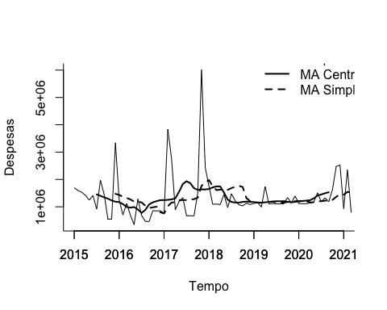

ma_simples_treinamento <- rollmean(treinamento_ts, k=36, align="right")  
ultima_ma <- tail(ma_simples_treinamento, 1)  
  
ma_simples_proj <- ts(rep(ultima_ma, 55), start=c(2015, 56), end = c(2015, 75), freq=12)  
  
plot(treinamento_ts, ylim=c(342000, 6013000), ylab="Despesas", xlab="Tempo", bty="l", xaxt="n", xlim=c(2015,2021))  
axis(1, at=seq(2015, 2021), labels=format(seq(2015, 2021)))  
lines(ma_simples_treinamento, lwd=2, col="blue")  
lines(ma_simples_proj, lwd=2, lty=2, col="blue")  
lines(validacao_ts)

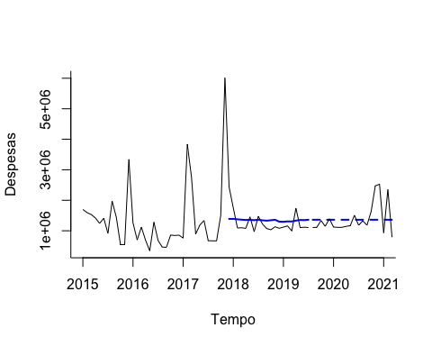

plot(treinamento_ts-ma_simples_treinamento, xlab="Tempo", ylab="Resíduos", ylim=c(-1500000, 4000000), bty="l")

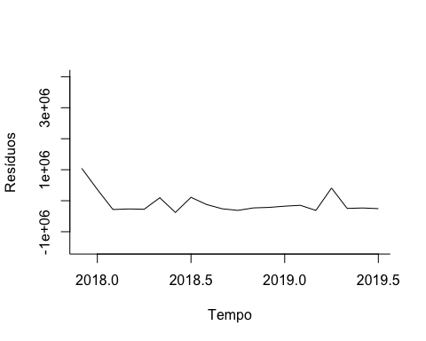

Acf(treinamento_ts-ma_simples_treinamento)

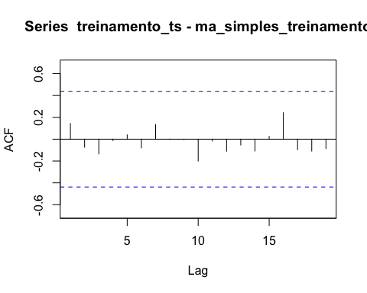

checkresiduals(treinamento_ts-ma_simples_treinamento, test="LB")

## Warning in modeldf.default(object): Could not find appropriate degrees of  
## freedom for this model.

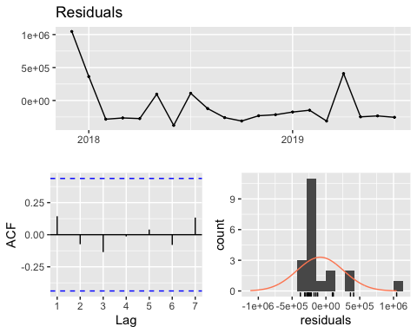

accuracy(ma_simples_treinamento, treinamento_ts)

## ME RMSE MAE MPE MAPE ACF1 Theil's U  
## Test set -84558.58 346045.6 286905.3 -12.22114 22.33803 0.1438404 0.7661441

accuracy(ma_simples_proj, validacao_ts)

## ME RMSE MAE MPE MAPE ACF1 Theil's U  
## Test set 20917.06 483925 350275.8 -7.912854 24.07041 0.0563613 0.7662608

O MAPE do modelo de média móvel também foi superior ao MAPE do Modelo Naive. Modelo de tendência exponencial:

#Estima o modelo de tendência exp  
modelo_tendencia_exp <- tslm(treinamento_ts ~ trend, lambda=0)  
  
#resumo do modelo  
summary(modelo_tendencia_exp)

##   
## Call:  
## tslm(formula = treinamento_ts ~ trend, lambda = 0)  
##   
## Residuals:  
## Min 1Q Median 3Q Max   
## -1.1822 -0.2749 -0.0569 0.2597 1.6501   
##   
## Coefficients:  
## Estimate Std. Error t value Pr(>|t|)   
## (Intercept) 13.895357 0.142909 97.232 <2e-16 ***  
## trend 0.001824 0.004440 0.411 0.683   
## ---  
## Signif. codes: 0 '***' 0.001 '**' 0.01 '*' 0.05 '.' 0.1 ' ' 1  
##   
## Residual standard error: 0.5227 on 53 degrees of freedom  
## Multiple R-squared: 0.003174, Adjusted R-squared: -0.01563   
## F-statistic: 0.1688 on 1 and 53 DF, p-value: 0.6829

#Verificando resíduos  
  
#Plotando os resíduos  
plot(modelo_tendencia_exp$residuals, xlab="Tempo", ylab="Resíduos", ylim=c(-0.5, 0.5), bty="l")

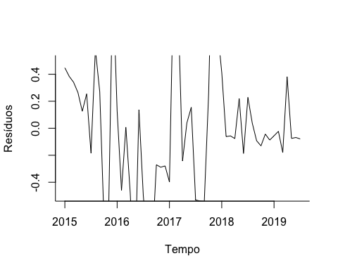

#calcula a autocorrelação dos resíduos  
Acf(modelo_tendencia_exp$residuals)

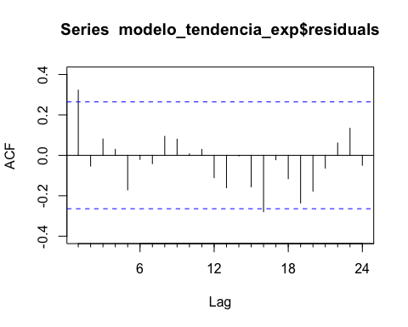

#verifica os resíduos com teste de Ljung-Box  
checkresiduals(modelo_tendencia_exp, test="LB")

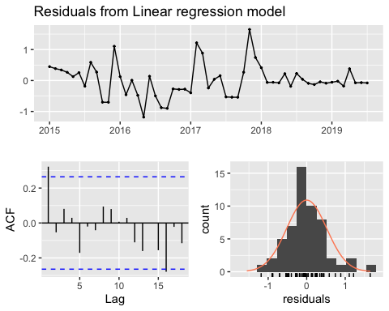

##   
## Ljung-Box test  
##   
## data: Residuals from Linear regression model  
## Q* = 9.7166, df = 9, p-value = 0.3739  
##   
## Model df: 2. Total lags used: 11

#CHeca a acuracia

Novamente o MAPE foi pior do que o modelo Naïve.

## Modelo de suavização exponencial (ZZZ)

modelo_ses1 <- ets(treinamento_ts, model = "ZZZ")  
summary(modelo_ses1)

## ETS(M,N,M)   
##   
## Call:  
## ets(y = treinamento_ts, model = "ZZZ")   
##   
## Smoothing parameters:  
## alpha = 1e-04   
## gamma = 1e-04   
##   
## Initial states:  
## l = 1300568.4885   
## s = 1.4752 1.7064 0.7051 0.6755 0.8023 0.686  
## 1.0165 0.661 0.8835 1.1596 1.3642 0.8648  
##   
## sigma: 0.5835  
##   
## AIC AICc BIC   
## 1717.447 1729.755 1747.557   
##   
## Training set error measures:  
## ME RMSE MAE MPE MAPE MASE ACF1  
## Training set 31092.59 835741 561803.4 -22.67877 48.85116 0.5964938 0.2137468

modelo_ses1_proj <- forecast(modelo_ses1, h=20, level=0.95)  
  
plot(modelo_ses1_proj, ylim=c(-300000, 6013000), ylab="Despesas", xlab="Tempo", bty="l", xaxt="n", xlim=c(2015,2021), flty=2)  
axis(1, at=seq(2015, 2021), labels=format(seq(2015, 2021)))  
lines(modelo_ses1$fitted, lwd=2, col="blue")  
lines(validacao_ts)

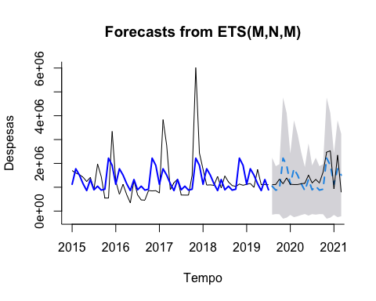

accuracy(modelo_ses1_proj, validacao_ts)

## ME RMSE MAE MPE MAPE MASE ACF1  
## Training set 31092.59 835741.0 561803.4 -22.678775 48.85116 0.5964938 0.2137468  
## Test set 32893.11 473001.4 390738.7 -3.419636 30.49871 0.4148662 0.1430581  
## Theil's U  
## Training set NA  
## Test set 0.8339434

Acf(modelo_ses1_proj$residuals)

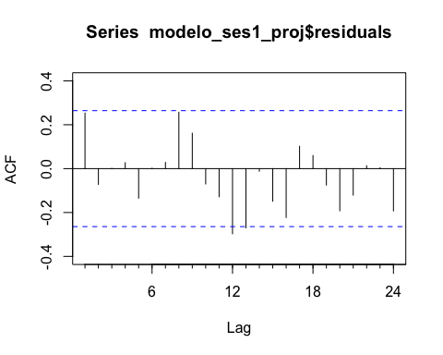

checkresiduals(modelo_ses1_proj, test="LB")

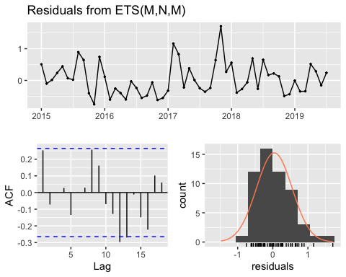

##   
## Ljung-Box test  
##   
## data: Residuals from ETS(M,N,M)  
## Q* = 31.379, df = 3, p-value = 7.074e-07  
##   
## Model df: 14. Total lags used: 17

## Modelo Arima:

#plota o grafica da projecao  
par(mfrow=c(2,2))  
plot(db_ts, ylab="Despesas", xlab="Tempo", bty="l", xlim=c(2015,2021.25), main=("Serie sem diff"))  
plot(diff(db_ts, lag=1), ylab="Despesas", xlab="Tempo", bty="l", xlim=c(2015,2021.25), main=("diff lag 1"))  
plot(diff(db_ts, lag=12), ylab="Despesas", xlab="Tempo", bty="l", xlim=c(2015,2021.25), main=("diff lag 12"))  
plot(diff(diff(db_ts, lag=12), lag=1), ylab="Despesas", xlab="Tempo", bty="l", xlim=c(2015,2021.25), main=("diff lag 12 e entao diff lag 1"))

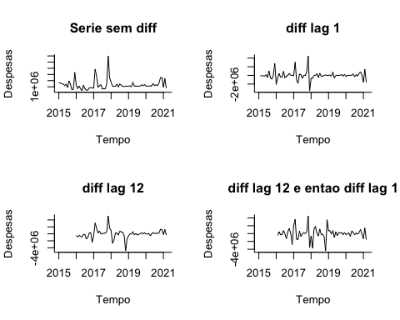

#checar estacionariedade  
checkresiduals(db_ts)

## Warning in modeldf.default(object): Could not find appropriate degrees of  
## freedom for this model.

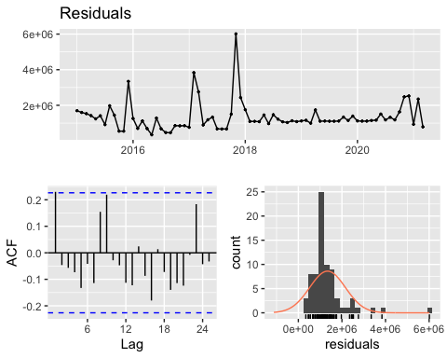

checkresiduals(diff(db_ts, lag=1))

## Warning in modeldf.default(object): Could not find appropriate degrees of  
## freedom for this model.

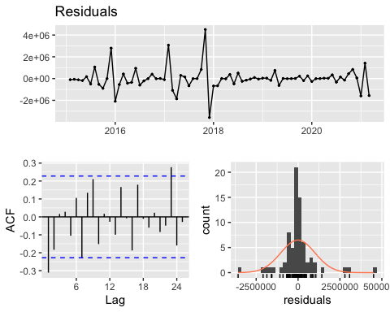

checkresiduals(diff(db_ts, lag=12))

## Warning in modeldf.default(object): Could not find appropriate degrees of  
## freedom for this model.

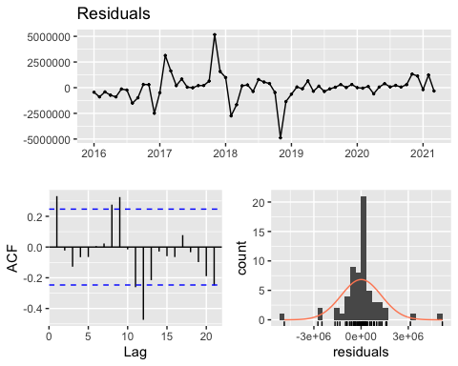

checkresiduals(diff(diff(db_ts, lag=12), lag=1))

## Warning in modeldf.default(object): Could not find appropriate degrees of  
## freedom for this model.

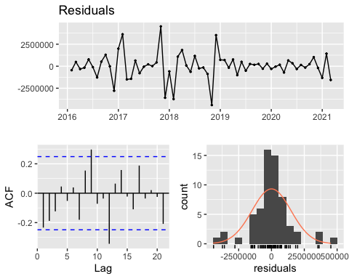

#diferencia 1 vez  
db_ts_diff <- diff(db_ts, lag=1)  
  
#executa o teste de KPSS  
summary(ur.kpss(db_ts))

##   
## #######################   
## # KPSS Unit Root Test #   
## #######################   
##   
## Test is of type: mu with 3 lags.   
##   
## Value of test-statistic is: 0.0621   
##   
## Critical value for a significance level of:   
## 10pct 5pct 2.5pct 1pct  
## critical values 0.347 0.463 0.574 0.739

#executa o teste de KPSS  
summary(ur.kpss(db_ts_diff))

##   
## #######################   
## # KPSS Unit Root Test #   
## #######################   
##   
## Test is of type: mu with 3 lags.   
##   
## Value of test-statistic is: 0.0283   
##   
## Critical value for a significance level of:   
## 10pct 5pct 2.5pct 1pct  
## critical values 0.347 0.463 0.574 0.739

#executa o teste de ADF  
summary(ur.df(db_ts))

##   
## ###############################################   
## # Augmented Dickey-Fuller Test Unit Root Test #   
## ###############################################   
##   
## Test regression none   
##   
##   
## Call:  
## lm(formula = z.diff ~ z.lag.1 - 1 + z.diff.lag)  
##   
## Residuals:  
## Min 1Q Median 3Q Max   
## -1654824 -47104 130667 392927 4955334   
##   
## Coefficients:  
## Estimate Std. Error t value Pr(>|t|)   
## z.lag.1 -0.16690 0.07501 -2.225 0.0293 *  
## z.diff.lag -0.23470 0.11726 -2.002 0.0491 *  
## ---  
## Signif. codes: 0 '***' 0.001 '**' 0.01 '*' 0.05 '.' 0.1 ' ' 1  
##   
## Residual standard error: 951900 on 71 degrees of freedom  
## Multiple R-squared: 0.1585, Adjusted R-squared: 0.1348   
## F-statistic: 6.688 on 2 and 71 DF, p-value: 0.002182  
##   
##   
## Value of test-statistic is: -2.2251   
##   
## Critical values for test statistics:   
## 1pct 5pct 10pct  
## tau1 -2.6 -1.95 -1.61

#executa o teste de ADF  
summary(ur.df(db_ts_diff))

##   
## ###############################################   
## # Augmented Dickey-Fuller Test Unit Root Test #   
## ###############################################   
##   
## Test regression none   
##   
##   
## Call:  
## lm(formula = z.diff ~ z.lag.1 - 1 + z.diff.lag)  
##   
## Residuals:  
## Min 1Q Median 3Q Max   
## -2083031 -346857 -117341 153056 4853907   
##   
## Coefficients:  
## Estimate Std. Error t value Pr(>|t|)   
## z.lag.1 -1.7326 0.1858 -9.326 6.68e-14 ***  
## z.diff.lag 0.3185 0.1162 2.741 0.00777 **   
## ---  
## Signif. codes: 0 '***' 0.001 '**' 0.01 '*' 0.05 '.' 0.1 ' ' 1  
##   
## Residual standard error: 942200 on 70 degrees of freedom  
## Multiple R-squared: 0.6862, Adjusted R-squared: 0.6772   
## F-statistic: 76.53 on 2 and 70 DF, p-value: < 2.2e-16  
##   
##   
## Value of test-statistic is: -9.3264   
##   
## Critical values for test statistics:   
## 1pct 5pct 10pct  
## tau1 -2.6 -1.95 -1.61

#############################################################  
# MODELO ARIMA  
#############################################################  
  
par(mfrow=c(1,2))  
plot(db_ts)  
plot(db_ts_diff)

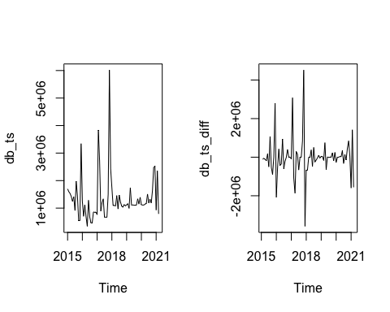

par(mfrow=c(1,1))  
  
ajuste_sazonal_db <- db_ts-db_ts_diff  
  
plot(ajuste_sazonal_db)

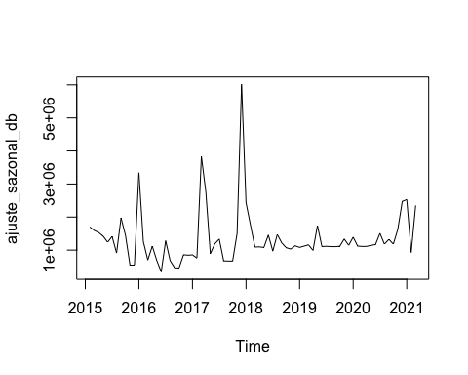

#separa as amostras em treinamento e teste  
  
#define o tamanho da amostra de teste  
  
#define o tamanho da amostra de treinamento  
amostra_treino <- length(db_ts_diff) - amostra_validacao  
  
  
  
#cria a serie temporal de treinamento  
treinamento_ts_diff <- window(db_ts_diff, start=c(2015, 1), end=c(2015, amostra_treino))

## Warning in window.default(x, ...): 'start' value not changed

#cria a serie temporal de teste  
validacao_ts_diff <- window(db_ts_diff, start=c(2015, amostra_treino + 1), end=c(2015,amostra_treino + amostra_validacao))  
  
  
#executa o teste de KPSS  
summary(ur.kpss(treinamento_ts_diff))

##   
## #######################   
## # KPSS Unit Root Test #   
## #######################   
##   
## Test is of type: mu with 3 lags.   
##   
## Value of test-statistic is: 0.0368   
##   
## Critical value for a significance level of:   
## 10pct 5pct 2.5pct 1pct  
## critical values 0.347 0.463 0.574 0.739

#executa o teste de ADF  
summary(ur.df(treinamento_ts_diff))

##   
## ###############################################   
## # Augmented Dickey-Fuller Test Unit Root Test #   
## ###############################################   
##   
## Test regression none   
##   
##   
## Call:  
## lm(formula = z.diff ~ z.lag.1 - 1 + z.diff.lag)  
##   
## Residuals:  
## Min 1Q Median 3Q Max   
## -2117586 -433296 -204615 59191 4823541   
##   
## Coefficients:  
## Estimate Std. Error t value Pr(>|t|)   
## z.lag.1 -1.7127 0.2161 -7.926 2.48e-10 ***  
## z.diff.lag 0.3351 0.1351 2.481 0.0166 *   
## ---  
## Signif. codes: 0 '***' 0.001 '**' 0.01 '*' 0.05 '.' 0.1 ' ' 1  
##   
## Residual standard error: 1065000 on 49 degrees of freedom  
## Multiple R-squared: 0.6815, Adjusted R-squared: 0.6685   
## F-statistic: 52.42 on 2 and 49 DF, p-value: 6.713e-13  
##   
##   
## Value of test-statistic is: -7.9263   
##   
## Critical values for test statistics:   
## 1pct 5pct 10pct  
## tau1 -2.6 -1.95 -1.61

#calcula a ACF  
Acf(treinamento_ts_diff)

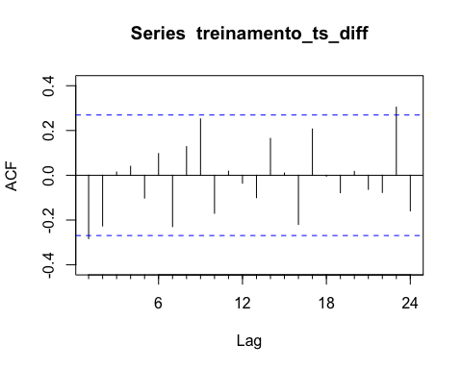

#calcula a PCF  
Pacf(treinamento_ts_diff)

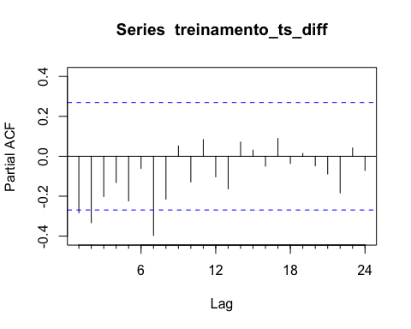

#Modelo Arima  
Modelo_ARIMA <- Arima(treinamento_ts_diff, order = c(2,1,1))  
  
#resumo modelo  
summary(Modelo_ARIMA)

## Series: treinamento_ts_diff   
## ARIMA(2,1,1)   
##   
## Coefficients:  
## ar1 ar2 ma1  
## -0.3578 -0.3104 -1.000  
## s.e. 0.1307 0.1290 0.051  
##   
## sigma^2 estimated as 1.136e+12: log likelihood=-796.59  
## AIC=1601.18 AICc=1602.04 BIC=1608.99  
##   
## Training set error measures:  
## ME RMSE MAE MPE MAPE MASE ACF1  
## Training set 28465.6 1024914 570511.2 6371.105 6675.536 0.4752428 -0.08119995

#projeta os proximos 12 meses  
modelo_ARIMA_proj <- forecast(Modelo_ARIMA, h=amostra_validacao, level=0.95)  
#plota o grafica da projecao  
plot(modelo_ARIMA_proj, ylab="Despesa", xlab="Tempo", bty="l", xaxt="n", xlim=c(2015,2024.25), flty=2)  
  
axis(1, at=seq(2015, 2024, 1), labels=format(seq(2015, 2024, 1)))  
  
lines(Modelo_ARIMA$fitted, lwd=2, col="blue")  
  
lines(validacao_ts_diff)

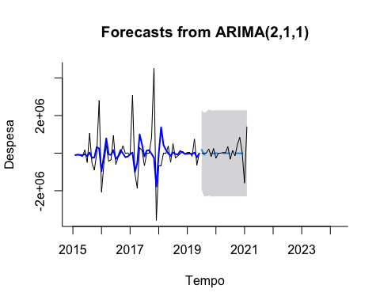

#verifica precisao  
accuracy(modelo_ARIMA_proj, validacao_ts_diff)

## ME RMSE MAE MPE MAPE MASE  
## Training set 28465.60 1024914.1 570511.2 6371.10531 6675.5360 0.4752428  
## Test set 64217.44 548342.3 332683.2 17.39917 547.5184 0.2771291  
## ACF1 Theil's U  
## Training set -0.08119995 NA  
## Test set -0.38972754 1.276779

#função auto.arima  
auto.arima(treinamento_ts_diff, seasonal = FALSE, stepwise=FALSE, approximation = FALSE)

## Series: treinamento_ts_diff   
## ARIMA(2,0,0) with zero mean   
##   
## Coefficients:  
## ar1 ar2  
## -0.3706 -0.3230  
## s.e. 0.1288 0.1271  
##   
## sigma^2 estimated as 1.091e+12: log likelihood=-808.87  
## AIC=1623.73 AICc=1624.22 BIC=1629.64

O modelo ARIMA teve um desempenho pior entre os modelos apresentados.

## Conclusão:

Após todos os modelos testados e analisados conclui-se pela performance do modelo de suavização exponencial. Seus erros RMSE e MAPE são inferiores a todos os outros modelos, e a autocorrelação de seus resíduos não é estatisticamente relevante.